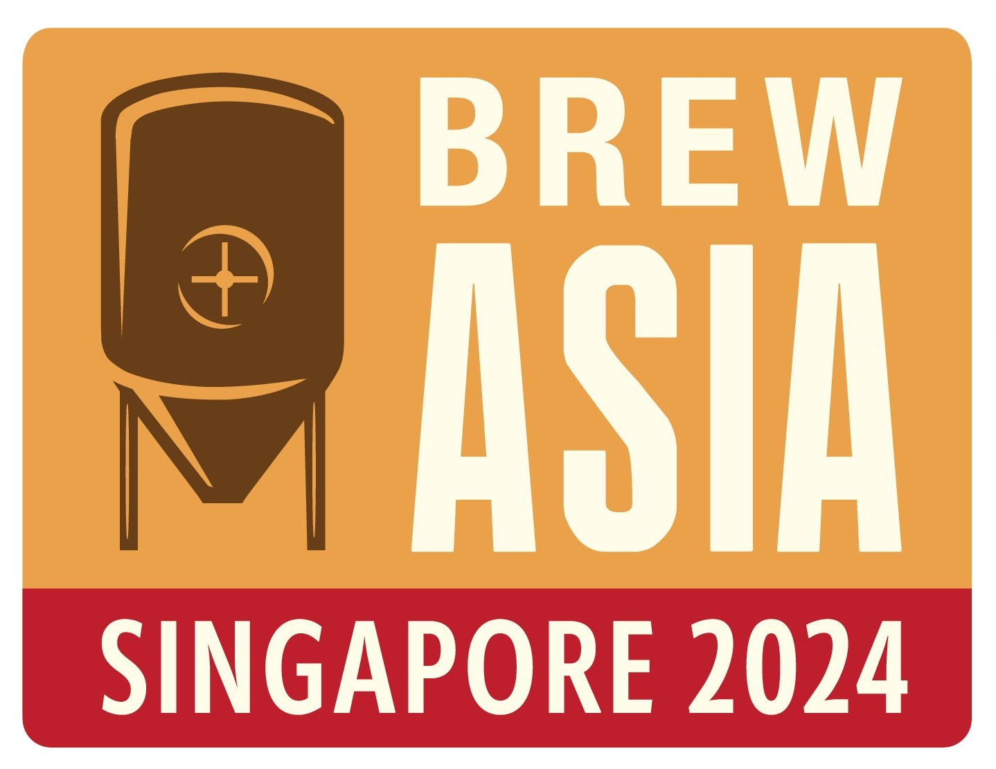

Suntec Convention & Exhibition Centre
3rd & 4th October 2024

CALL FOR ABSTRACTS
Brew Asia 2024, Singapore

Proposed presentation title (max 150 characters, including spacing)

Presentation/Workshop summary (min 250, max 400 words)

Presenter’s Name

Presenter’s Company

Presenter’s Job Title

Brief presenter’s work biography (max 150 words demonstrating experience in the topic proposed)

Number of years presenting experience (please note presenters must have at least 5 years live presenting experience)

Declare any corporate affiliation (if you are presenting a product or service on behalf of another company)

SUBMISSION DEADLINE 5TH JULY 2024

